Count Function & the Group by clause

select subscription, count(subscription) as total from club group by subscription;

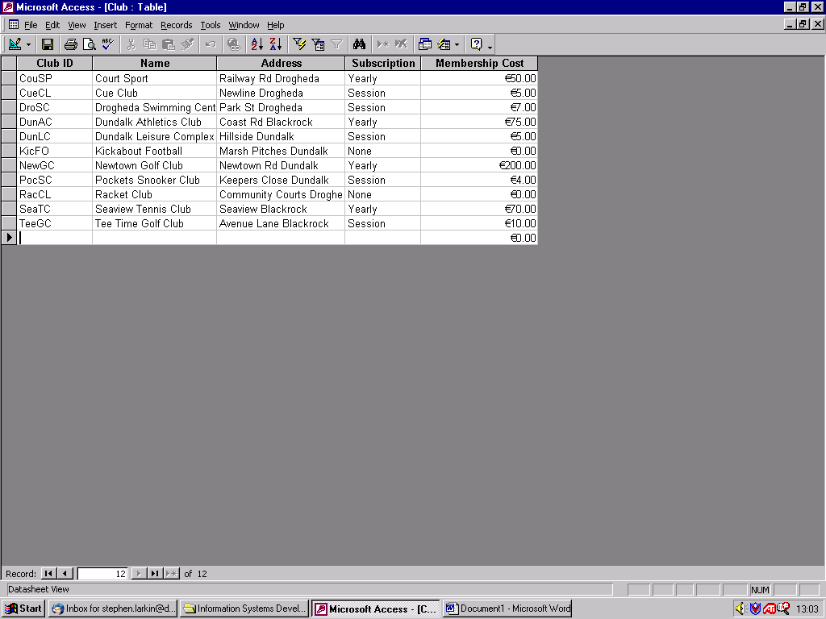

select subscription, count(subscription) as total from club group by subscription;

Subscription | Total
Yearly | 1
Session | 1
Session | 1
Yearly | 1
Session | 1
None | 1
Yearly | 1
Session | 1
None | 1
Yearly | 1
Session | 1

select subscription, count(subscription) as total from club group by subscription;

Subscription | Total
Yearly | 4
Session | 5
None | 2

